**CSC 706 Project 1:** *Animated Robots in an OpenGL World*

**Group Members:** Robert Kigobe, Dominic Klusek, Novichenko Konstantin

**Date:** 4/30/2021

Animation is the process of manipulating figures to create the illusion of movement and create stories. Animation is usually done on a frame-by-frame basis to create intricate scenes full of movement, effects, or scenes transitions. Computer animation using 3d objects focuses around utilizing simple transformations such as translation, rotation, and scaling; and performing these transformations on a frame-by-frame basis to create the animation. Using OpenGL and GLUT creation of animations can be done using callback functions which on each call will manipulate the objects in the scene and create whatever movement the programmer desires. For Project 1 the task was to learn this manipulation to animate robot people, a menu to control animation, lighting, and the camera, finally create a camera which could move around the scene.

Part 1 centers around a single robot person. This provided robot person has a head, torso, arms made of a single segment each, hands, legs mad of a single segment each, and feet. The first task was simple; spin the hands and feet; since each of these parts were separate from the arms and legs a *glRotatef*() function calls were added and a global variable to control the rotation was added. This global variable *rotationAngle* was then modified with each call of the *timer*() callback function. This covered the base assignment; next was further manipulation which we decided was to make the robot dance. The model was changed after some brainstorming on the dance; the legs were modified to have 2 segments and knees joints; the feet were also changed to be ovals rather than perfect spheres using the *glScalef*() function and stretching the sphere in 1 direction the model was also given a top hat made from some cylinders to make the decorative band and main body and flattened spheres to create the rim and close the top of the hat. Then a cane was given, which was made with a series of rotated cylinders. The robot’s dance was simple, a small bending of the knees that was created by rotating the leg segments, then to show the body being affected by the legs bending, the body, knees, arms, hands, cane, and hat would move in sync with the legs movement, and since the hands are spinning, the robot spins the cane as well. The final model is shown in Figure 1.

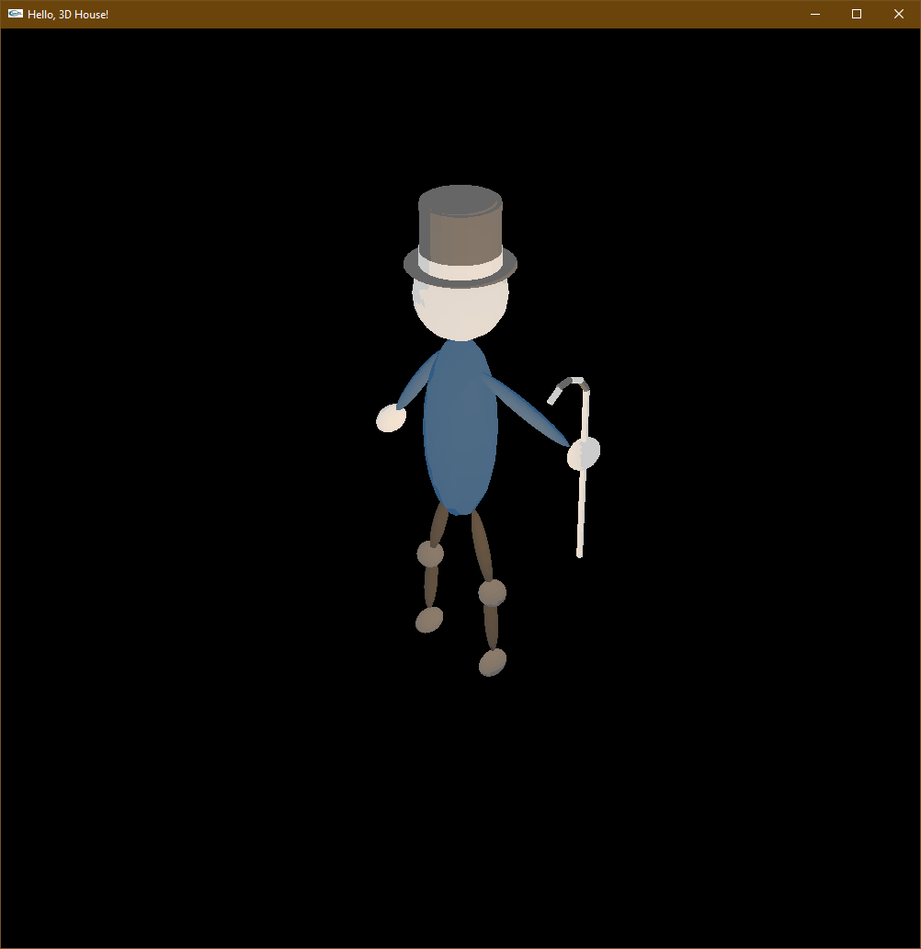

Figure 1. Finished robot model.

Part 2 of the project expands on Part 1. For part 2 the robot person takes its 2 children somewhere, and we are tasked with drawing said scene. We decided on the robot parent taking its children to the park. The parent robot is the same as the one from the part 1; dance and all so there is not much to talk about with them. For the children, the top hat and cane were removed from the base robot person model, and then they were resized, posed, and animated separately from the parent robot. The first child sits on the floor by having its legs rotated and posed to simulate them crossing their legs; and in place of the top hat, they have a space helmet made from a wireTetrahedron. The first child is animated to clap its hands by rotating the hands and arms; then offsetting them; no animation was placed on the body, legs, or head which remain stationary.. For the second child we built a swingset utilizing some cube that were scaled to rectangular prisms and the rotating in a way to create a standard A-frame swingset. The seat was another cube that was scaled to look like a plank of wood, and the chains were cylinders. The second child is sitting on the swing seat with its legs bent at right angles, and a second joint was added to its arms so that they could bend and grab onto the swing chains. The swing seat and chains were animated to move in an arc from $(-{45}^{°},{45}^{°})$, the seat and chains were rotated at the origin, offset, and then rotated around the x axis to create this arc, and the child was similarly rotated, offset, and then rotated around the x axis; in addition the feet and calves were animated to show the legs bending as one would when on a swing; straightening out when going forward and bending in when going backwards. Then for extra scenery we have grass, some trees, a concrete path with some flowers around it, and finally a spinning merry go round. The final figure is shown in Figure 2.

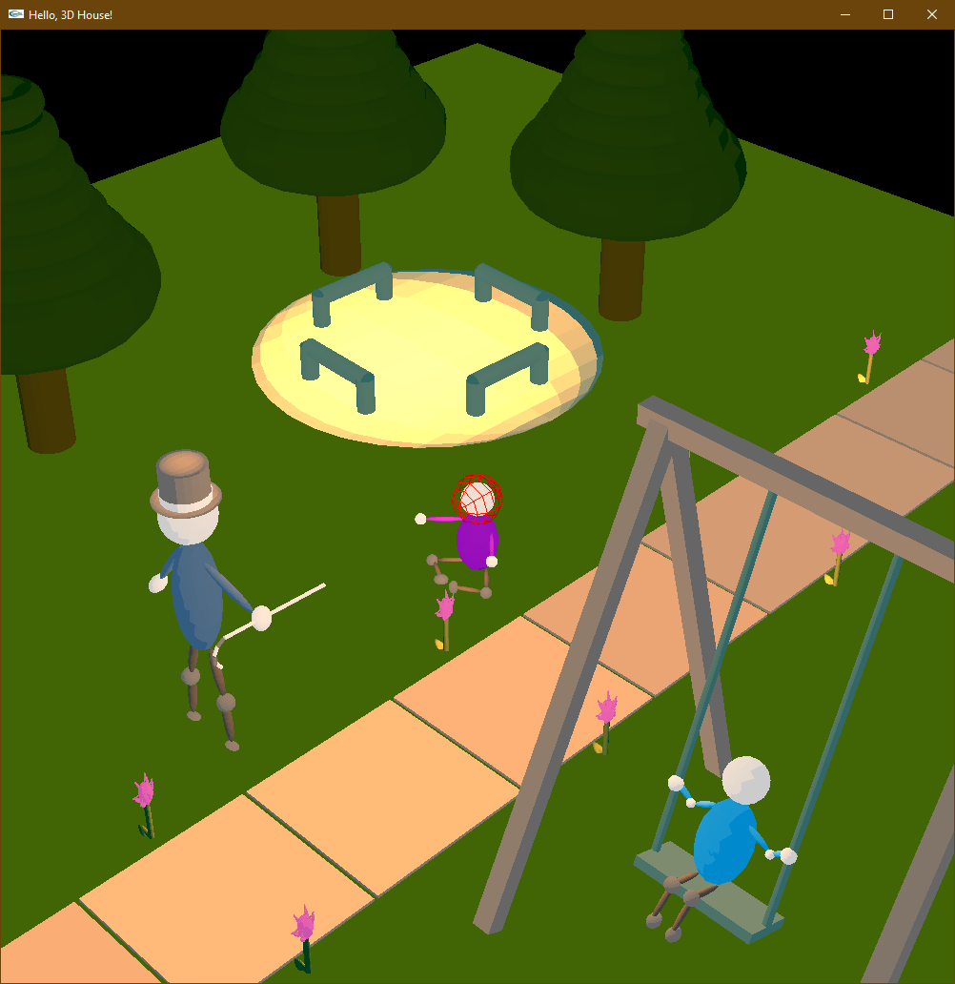

Figure 2. The happy robot family at the park

Some problems that we ran into was with missing pushes and pops to the stack matrix; which caused problems ranging from limbs flying away during animations, animations not lining up properly with the figures or objects in the scene(such as the swing being ahead of the swinger), and finally spinning the camera around the scene. Other than that problem, setting up the animations and ensuring that they line up correctly was difficult at first, but became easier as we began to understand how to make utilize the transformation and rotation functions more effectively. There were even some lagging issues due to the flower petals being made up or a large number of complex teapots, and the constant lighting and redrawing; so we reduced the number of flower petals We were also thinking of adding some textures to the objects, but ultimately deciding to refrain from it, so that we could ensure that the animations would be properly done, and that all the scene objects sit correctly in the scene.

This project was a great exploration into animation; the combination of object animation and creating animations while ensuring that the body parts do not become disconnected involved sometime manually tracking offsets, but through the combination of a large number of global variables and using if statements to control the animations playing and resetting allowed for quick modification of those global variables. In future projects we hope to be able to include textures, and play more with the lighting, and possibly shading to create better shadows and add more realism to our 3d scenes.